|  |  |  |
| --- | --- | --- |
|  |  |  |
|  | **2023 — 2 0 24**  **School — Home**  **C o m p a c t**      ***Courtney E. Blake, Principal***  ***River Oaks Middle School 4700 New Bern Ave, Raleigh, NC 27610,***  ***919-231-5600 Ph.***  ***919-346-6510 Fax***  **http://www.wcpss.net/riveroaksms**  ***Seeking New Beginnings!*** |  |
|  |  |  |

**W h a t is a S c h o o l – Home C o m p a c t?**

A shared responsibility for the improvement of student academic achievement and it builds a partnership between teacher, student, and parent. The parents, teachers and students worked jointly together sharing ideas to develop the school/home compact.

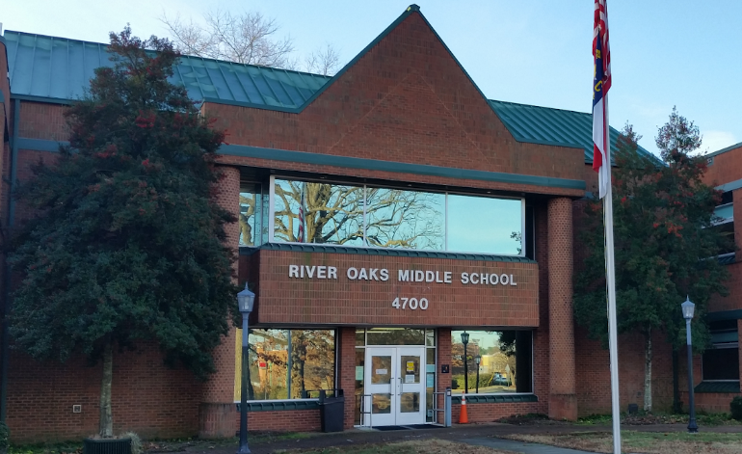

# What does it Mean to be a Title One School?

The emphasis in a schoolwide Title I school is on serving all students. Schoolwide programs maximize the impact of Title I funding in that all students in the school are served as funds are used to improve the entire educational program.

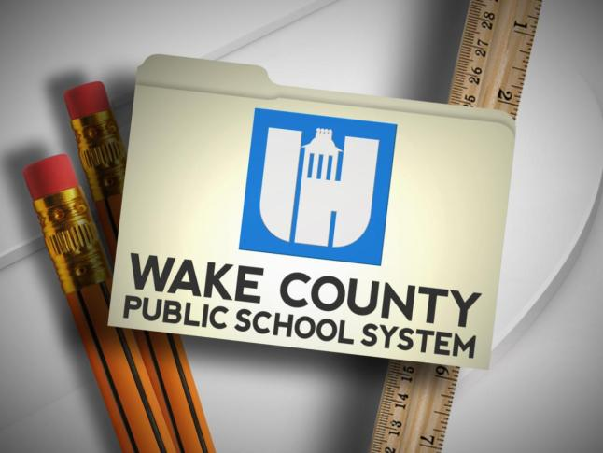

**Building Partnerships**

River Oaks Middle School offers ongoing events and programs to provide parents and students with

access to our staff. Please contact our school to learn about these great opportunities and more.

* Community Partners
* Family Nights
* Open House/ Curriculum Night
* PowerSchool Access Center
* Student Led conferences
* Parent Teacher Conferences
* School Tours
* Math and ELA Academic Workshops
* New Student Orientations

**For more information contact:**

**Mrs. Makiya Wilson, Counselor**

**919-231-5600 x27287,** [mwilson@wcpss.net](mailto:mwilson@wcpss.net)

**School and Home Communication**

* **School messenger**

**(Email and Voice Communication)**

* **School Website**
* **Progress Reports (every 3 weeks)**
* **Parent—Teacher Conferences**

##### Our Mission

Wake County Public School System will provide a relevant and engaging education and will graduate students who are collaborative, creative, effective communicators and critical thinkers.

##### Our Vision

River Oaks Middle School will work with each student to achieve their highest academic potential as they work to become productive members of society.

##### Wake County Public Schools District Goal

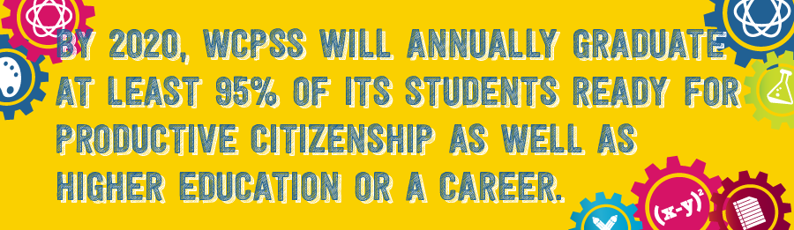:

##### River Oaks Middle S c h o o l G o a l s:

**Goal 1:**

* Teachers will support the ROMS PBIS plan by identifying and recognizing students for positive behaviors and will implement instructional strategies that engage students based on the individual needs of my students.

***ROMS School Administration, Staff and***

***Teachers, WE will:***

* Use the latest research to teach students.
* Provide open communication through folders, conferences, phone calls and notes.
* Establish collaboration with the classroom teacher for student instruction and scheduling/pull-out.
* Provide materials that are interesting and motivating.
* Help parents understand instructional practices,
* Plan meaningful lessons that meet individual student needs.
* Provide a safe school environment that promotes learning and encourages a partnership with the school.
* Employ effective classroom management skills.
* Promote a feeling of belonging for all

***ROMS Parents/Guardians, WE will:***

* Read nightly with my child.
* Help my child with his/her homework.
* Provide an appropriate area for doing

homework.

* Review and sign my child’s point sheet daily.
* Provide encouragement and positive reinforcement.
* Attend school activities & parent-teacher conferences.
* Communicate and work with the school to encourage my child’s learning and positive behavior.
* Ask specific questions to stimulate my child’s conversation/oral language skills
* Encourage regular & prompt attendance***ROMS Student, I will:***
* Complete my homework.
* Review my point sheet with my parent/s daily and return it signed the next school day.
* Read nightly with my parents.
* Participate in activities that help me learn.
* Participate in classroom activities.
* Ask questions when I need help.
* Help others.
* Be at school on time and regularly.
* Be responsible with my books, folders and school supplies.
* Be responsible for my actions and behavior each day.
* Be a good citizen by doing what is right because it is the right thing to do for myself and others.

**River Oaks Parents and Students:**

**Together WE can, together WE will strive for each student to reach his/her fullest potential while a part of our River Oaks family!**

***Seeking New Beginnings!***